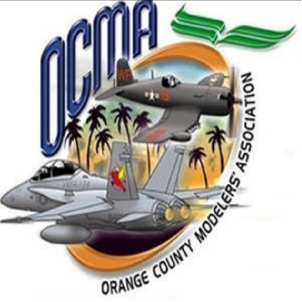
ORANGE COUNTY MODELERS ASSOCIATION
BOB SWENSON FLYING SITE APPLICATION

New _____ Renewal _____ Membership Badge Number ______________
(renewals not accepted after 12/31/2022)

Name: ______________________ _______________________ AMA# ______________ Expiration ________
Last Name First Name (Full AMA membership required and expiration must be 12/31/2023 or later) (Park Pilot membership does not meet site insurance requirements)

Address: _____________________________________________ City: __________________________________

State: __________ Zip: _______________ Email: __________________________________________________

Home Phone: ___________________________________ Cell Phone: ___________________________________

FAA Registration Number: ______________________________________ FAA Expiration Date: ______________
(Copy of FAA registration must be submitted with application) (Expiration must be in 2023 or later)

_______________________________________________ ____________________________________________
Participating Club Affiliation Modeling Interest (ex. Scale, Aerobatic, Heli, FPV, Quad)

Annual Membership: ______$140.00___
Initiation Fee: ______$ 50.00____ Amount Paid: ____________________________
Cash / Check

Make check payable to OCMA and mail to: Orange County Modelers Association
Must include copy of 2023 AMA card with application Attn: Greg Stone
Must include copy of FAA registration with application P.O. Box 28016
Anaheim, CA 92809

Email a passport size, current photo of yourself to gstone4@outlook.com when you submit your application.
The photo can be taken with your phone and either emailed or sent via text (949-413-0920). Include your name with the email or text.

An OCMA membership badge will be issued in your name permitting you to fly at the OCMA Flying Site. When flying at Bob Swenson Field you must have your OCMA Membership Badge, current AMA Card, and FAA Registration with you. Your OCMA Membership Badge must be worn in plain sight at all times.

When flying, if using non-2.4Ghz equipment, it is your responsibility to check with other pilots and notify of your frequency to be used.

By signing this form, you acknowledge understanding and agreement to comply with OCMA, AMA, and FAA rules. Upon non-renewal or cancellation of membership, gate access key must be returned to OCMA.

I further understand and accept that a Safety Officer or Field Marshall may suspend my OCMA Membership Badge for Safety and OCMA Flying Site Rule Violations.

___________________________________________________ _____________________________________
Member Signature Date

